SmartPlant 3D Isometrics v7
Isometric Drawings Extraction User Training

Table of Contents

LAB-1: WBS Assignment 1
LAB-2: Grouping by Piping Parts Iso Sheet 2
LAB-3: Generating WBS Isometric Drawings 4
LAB-4: Splitting WBS Isometric Drawings Sheets 6

LAB-1: WBS Assignment

- Open a Session file with Imperial Units. Define Workspace to show Unit04 and WBS Project1
- Set the active WBS project to “Project 1” as shown
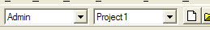
- Model the pipeline below from 41V-101 to suction nozzles on 41P-101A/B
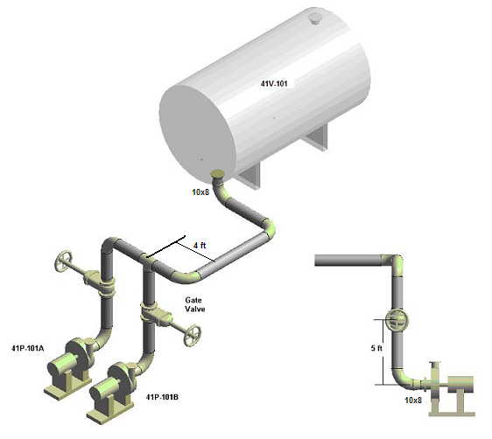
- Set the selection tool to Piping Parts and review the Relationship properties tab of any of the parts just placed. Verify membership in Project1 for WBS Project. Review Shaw Users Guide section “Claiming Parts After Creation” for details on claiming parts previously placed

LAB-2: Grouping by Piping Parts Iso Sheet

- Fence-select all piping parts modeled. Right click to select their properties page, set iso sheet number to 101 and OK form
- Start the Group Pipe Parts command and define the grouping parameters as shown here:
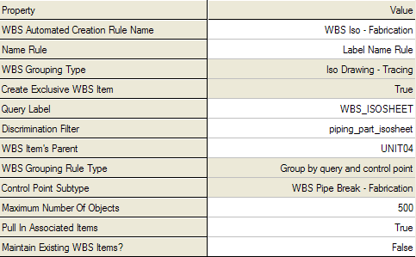
Notes: The query label WBS_ISOSHEET should be provided by the instructor with the training plant. Its format is “ISOSHEET- #”
The discrimination asking filter “piping_part_isosheet” should be provided, it should prompt user for the iso sheet number.
The WBS parent WBS-ISOS/ UNIT04 should also be provided with the WBS Project1 hierarchy
- Select OK and verify that the iso sheet was created successfully.
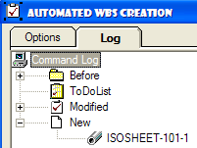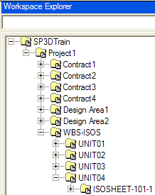
IMPORTANT: In early versions of SP3D V7, the resulting WBS Purpose for the WBS Items created comes out as “Iso Drawing – Tracing”. Review properties of the new ISOSHEET-101-1 and set that to “Iso Drawing – Fabrication” if necessary

LAB-3: Generating WBS Isometric Drawings

- Switch tasks to Drawings and Reports
- Navigate to the WBS folder for isometrics
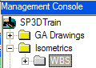
- Right-click on the WBS folder in the Management Console hierarchy and pick the New… entry from the resulting shortcut menu
- Once the “Add Component” dialog appears, activate the “Isometrics (by Query)” tab and select the “Shaw_WBS_Isometrics_DwgByQMgr” package
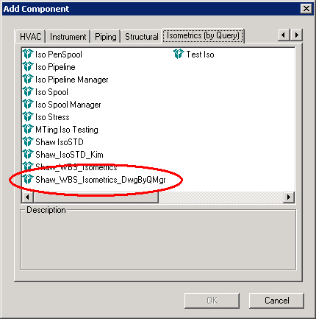
- Verify that a new component node named “WBS_Isometrics_DwgByQMgr” has been created in the hierarchy. Rename it to UNIT04
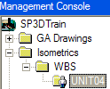
- Right-click on the “WBS_Isometrics_DwgByQMgr” named UNIT04 and pick the Setup… entry from the resulting shortcut menu
- Once the “Setup” dialog appears, set the value of the Filter field to “WBS_UNIT04” and use Package “Shaw_WBS_Isometrics”
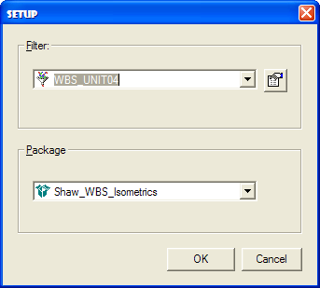
- Right click iso by query manager UNIT04 () and select Run Query. This should result in the following structure:
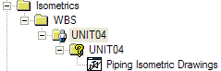
- Right click Piping Isometric Drawings (Or WBS Isometrics) and select Create Drawing(s). This will result in drawing ISOSHEET-101-1
- Right click drawing ISOSHEET-101-1 and select Update Now. If the extraction is successful it will result in the checkmark icon
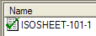
- Double click the drawing to view it
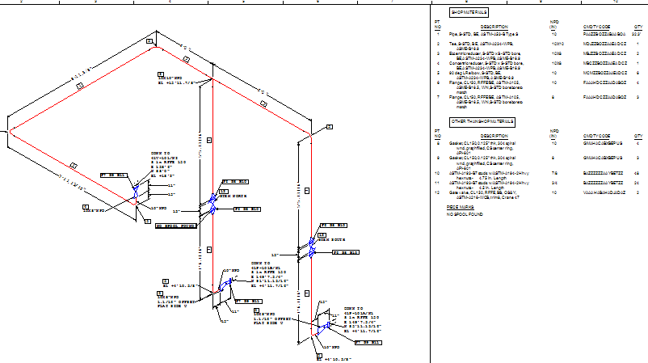

LAB-4: Splitting WBS Isometric Drawings Sheets

- Switch tasks to Piping
- Set the selection filter to Piping Parts
- Select the piping parts from the tank nozzle to the pipe before the Tee on the pipeline from Lab-1
Hint: Pick the flange at the nozzle, hold SHIFT key down and select the pipe before the Tee
- Open their properties page and set the iso sheet number to 102
- Start the Group Pipe Parts command and define the grouping parameters as shown here:
Note: If piping_part_isosheet is an asking filter, set it to “Begins with” and “10” for all parts to be processed (101 and 102)
IMPORTANT: In early versions of SP3D V7, the resulting WBS Purpose for the WBS Items created comes out as “Iso Drawing – Tracing”. Review properties of the new items and set WBS Purpose to “Iso Drawing – Fabrication” if necessary
- The new WBS hierarchy should look as follows (you may need to delete the old isosheet group due to a temporary bug)
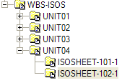
- Switch tasks to Drawings and Reports
- Navigate to “UNIT04>Piping Isometric Drawings” and use Create Drawing(s) again to re-define the new sheets. 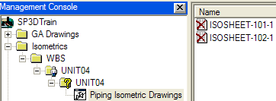
- Select both sheets and right click to launch Update Now
- Double click each successfully updated drawing to review its contents
